Testing NAT Functionality

Network   
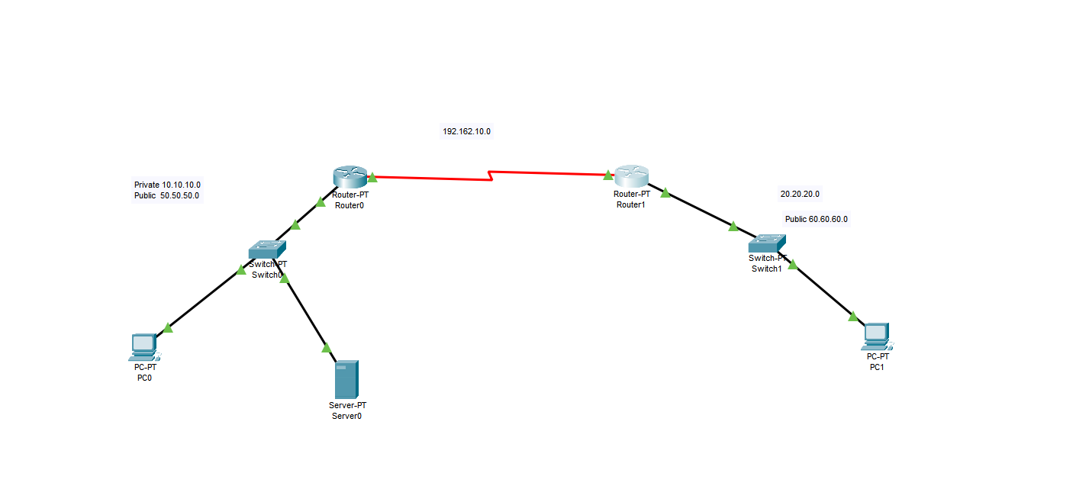  
Fig 1. Network Topology

Tasks:

1. Access a website from one of the PCs with a private IP address

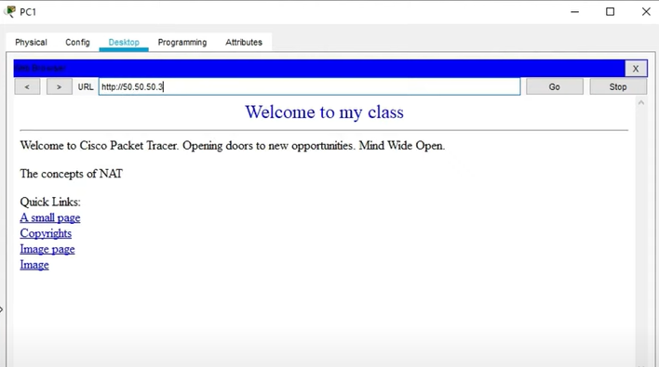  
Fig 2. PC1 accessing a website with private IP Address

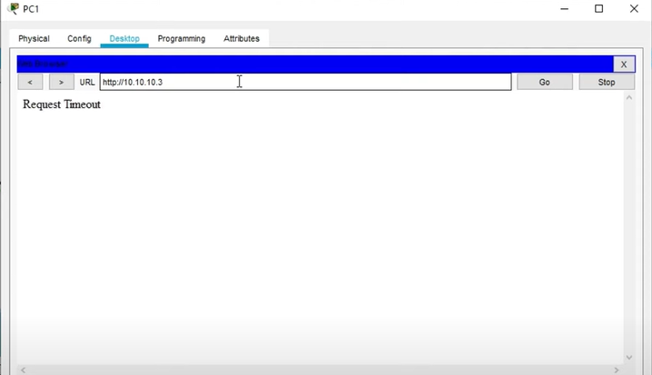  
Fig 3. PC1 PC1 accessing a website with private IP Address

1. Verify NAT translation on the router using appropriate commands.

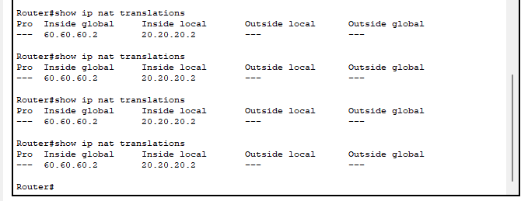  
Fig 4. NAT Translation

1. Discuss observations and insights regarding NAT's role in enabling internet access for devices with private IP addresses.

Network Address Translation (NAT) is essential for providing internet access to devices with private IP addresses. By allowing the translation of private IP addresses to public ones, NAT conserves public IPv4 address space, facilitates network segmentation, and enhances security by masking internal details. NAT operates in various modes, such as Static NAT, Dynamic NAT, and PAT, offering flexibility in addressing needs. While NAT has been a crucial tool in mitigating the IPv4 address exhaustion problem, the adoption of IPv6 may influence its role in the long term. Nonetheless, NAT continues to play a pivotal role in ensuring connectivity, security, and efficient resource utilization in contemporary networks.